# CS 255 System Design Document Template

This template lays out all the different sections that you need to complete for Project Two. Each section has guidance to prompt your thinking. You will need to continually reference the interview transcript as you work to make sure that you are addressing your client’s needs. There is no required length for the final document. Instead the goal is to complete each section based on what your client’s needs are. Remove this note when you are finished, and replace all bracketed text with the relevant information.

## UML Diagrams

### UML Use Case Diagram

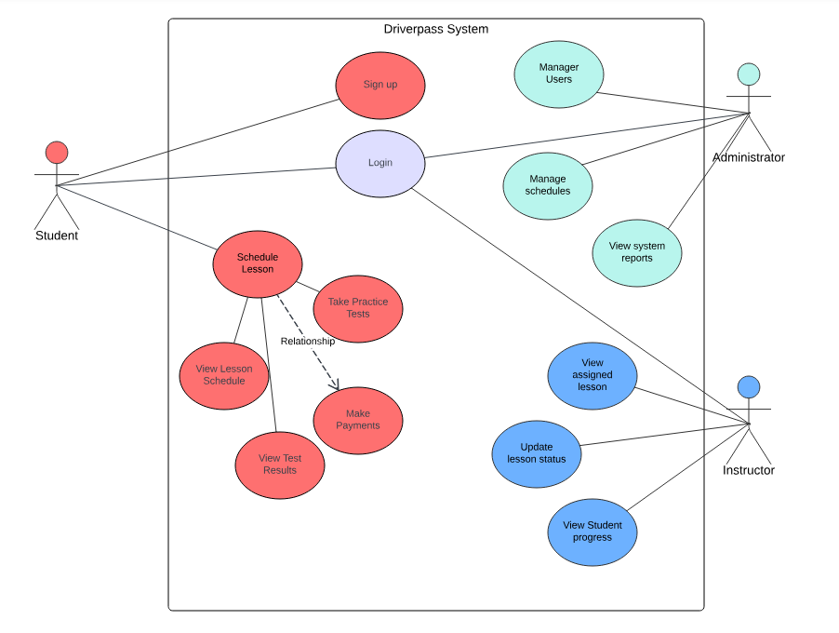

### UML Activity Diagrams

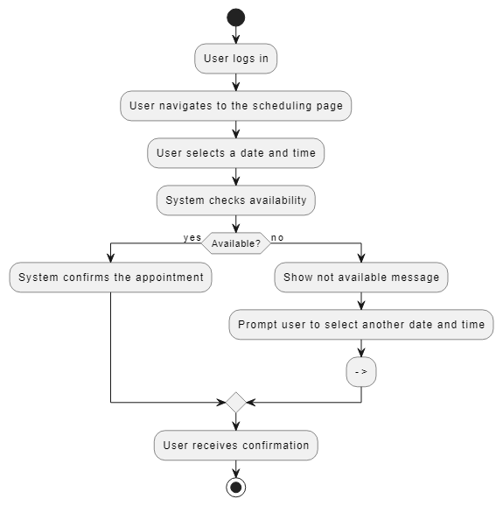

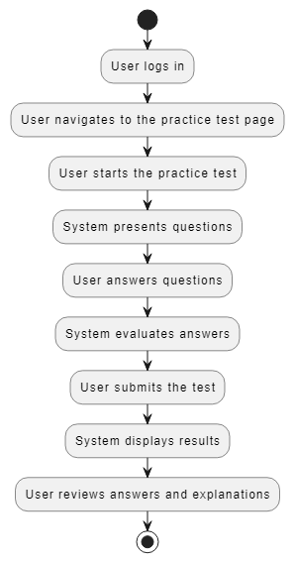

### UML Sequence Diagram

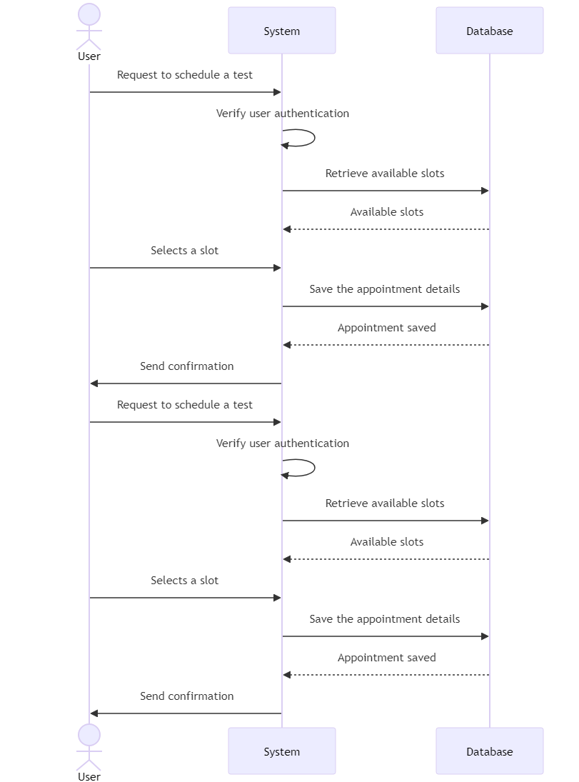

### UML Class Diagram

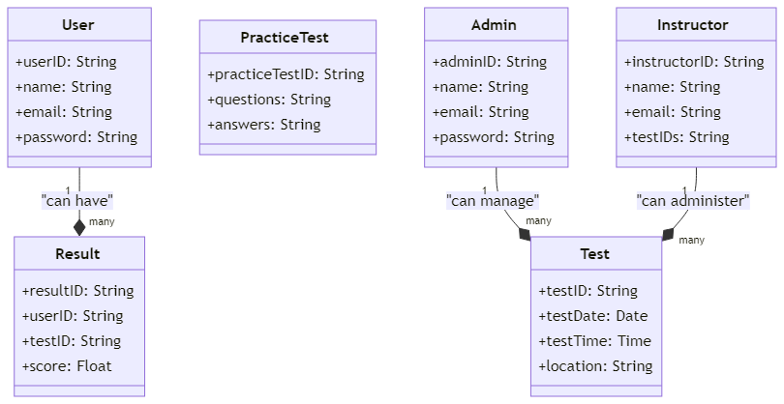

## Technical Requirements

**Hardware Requirements**

- Servers: High-performance servers are needed to host the DriverPass application and database.

- Client Devices: The system should be compatible with various devices, including desktops, laptops, tablets, and smartphones.

- Network Equipment: Reliable networking equipment is required to ensure seamless connectivity and communication between client devices and servers.

**Software Requirements**

- Operating System: The system should be compatible with Windows and Linux servers.

- Database Management System (DBMS): A relational database system such as MySQL or PostgreSQL should be used.

- Web Server: The application should be served using Apache or Nginx.

- Application Framework: The application should be developed using a suitable framework such as Node.js or Django.

- Front-End Technologies: The user interface should be built using HTML, CSS, JavaScript, and frameworks like React or Angular.

**Tools**

- Development Tools: An Integrated Development Environment (IDE) such as Visual Studio Code or IntelliJ IDEA should be used.

- Version Control: Git should be used for source code management and collaboration.

- CASE Tool: Lucidchart should be used to create and manage UML diagrams.

- Testing Tools: Automated testing tools such as Selenium for functional testing and JUnit for unit testing should be utilized.

**Infrastructure**

- Cloud Services: Cloud platforms like AWS, Azure, or Google Cloud should be used for scalable and reliable hosting.

- Security Measures: Robust security protocols, including SSL/TLS for data encryption, firewalls, and intrusion detection systems, should be implemented.

- Backup and Recovery: Regular automated backups and disaster recovery plans should be in place to ensure data integrity and availability.